# Packet Tracer - Investigate a VLAN Implementation

## Addressing Table

|  |  |  |  |  |
| --- | --- | --- | --- | --- |
| **Device** | **Interface** | **IP Address** | **Subnet Mask** | **Default Gateway** |
| S1 | VLAN 99 | 172.17.99.31 | 255.255.255.0 | N/A |
| S2 | VLAN 99 | 172.17.99.32 | 255.255.255.0 | N/A |
| S3 | VLAN 99 | 172.17.99.33 | 255.255.255.0 | N/A |
| PC1 | NIC | 172.17.10.21 | 255.255.255.0 | 172.17.10.1 |
| PC2 | NIC | 172.17.20.22 | 255.255.255.0 | 172.17.20.1 |
| PC3 | NIC | 172.17.30.23 | 255.255.255.0 | 172.17.30.1 |
| PC4 | NIC | 172.17.10.24 | 255.255.255.0 | 172.17.10.1 |
| PC5 | NIC | 172.17.20.25 | 255.255.255.0 | 172.17.20.1 |
| PC6 | NIC | 172.17.30.26 | 255.255.255.0 | 172.17.30.1 |
| PC7 | NIC | 172.17.10.27 | 255.255.255.0 | 172.17.10.1 |
| PC8 | NIC | 172.17.20.28 | 255.255.255.0 | 172.17.20.1 |
| PC9 | NIC | 172.17.30.29 | 255.255.255.0 | 172.17.30.1 |

## Objectives

**Part 1: Observe Broadcast Traffic in a VLAN Implementation**

**Part 2: Observe Broadcast Traffic without VLANs**

## Background

In this activity, you will observe how broadcast traffic is forwarded by the switches when VLANs are configured and when VLANs are not configured.

## Instructions

### Part 1: Observe Broadcast Traffic in a VLAN Implementation

#### Step 1: Ping from PC1 to PC6.

1. Wait for all the link lights to turn to green. To accelerate this process, click **Fast Forward Time** located in the bottom tool bar.

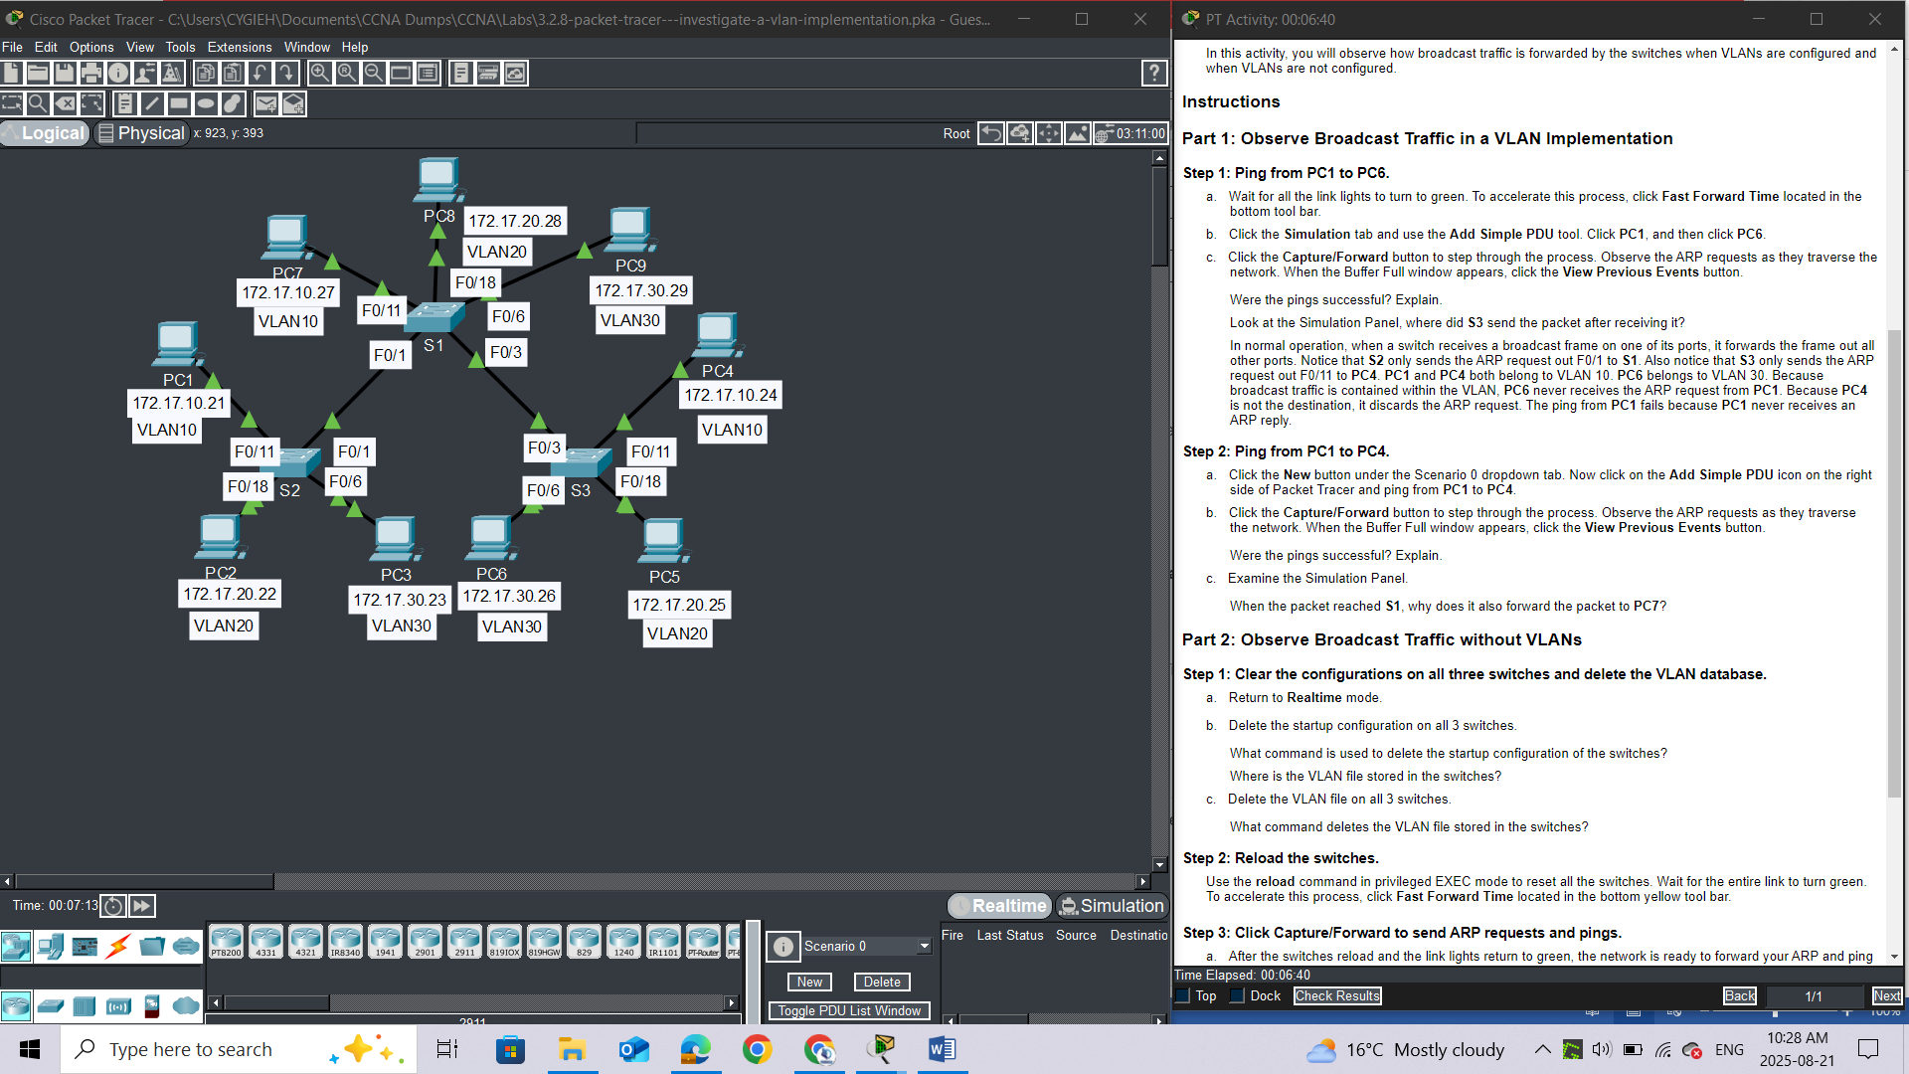

1. Click the **Simulation** tab and use the **Add Simple PDU** tool. Click **PC1**, and then click **PC6**.

c.     Click the **Capture/Forward** button to step through the process. Observe the ARP requests as they traverse the network. When the Buffer Full window appears, click the **View Previous Events** button.

#### **Questions:**

Were the pings successful? Explain.

Look at the Simulation Panel, where did **S3** send the packet after receiving it?

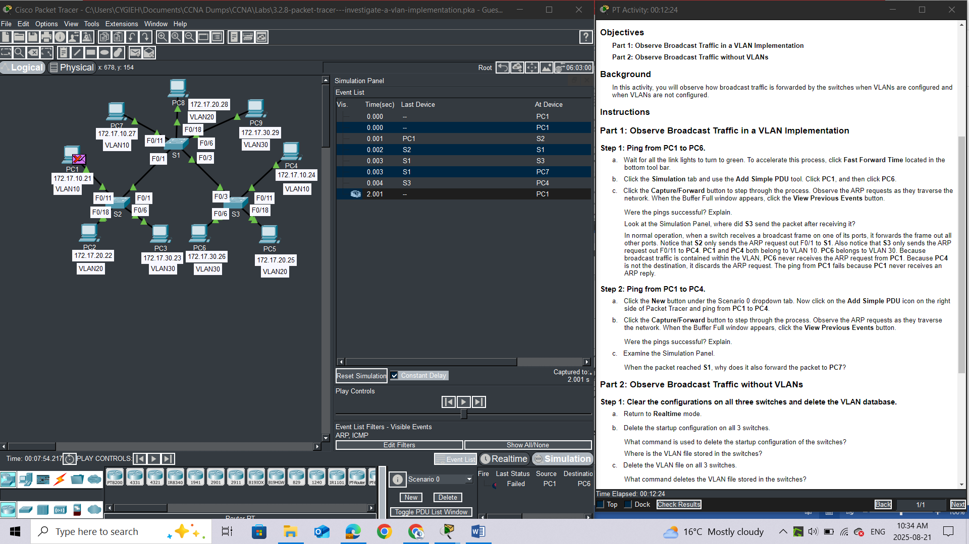

**ANSWER**

*In normal operation, when a switch receives a broadcast frame on one of its ports, it forwards the frame out all other ports. Notice that****S2****only sends the ARP request out F0/1 to****S1****. Also notice that****S3****only sends the ARP request out F0/11 to****PC4****.****PC1****and****PC4****both belong to VLAN 10.****PC6****belongs to VLAN 30. Because broadcast traffic is contained within the VLAN,****PC6****never receives the ARP request from****PC1****. Because****PC4****is not the destination, it discards the ARP request. The ping from****PC1****fails because****PC1****never receives an ARP reply.*

#### Step 2: Ping from PC1 to PC4.

a.     Click the **New** button under the Scenario 0 dropdown tab. Now click on the **Add Simple PDU** icon on the right side of Packet Tracer and ping from **PC1** to **PC4**.

b.     Click the **Capture/Forward** button to step through the process. Observe the ARP requests as they traverse the network. When the Buffer Full window appears, click the **View Previous Events** button.

#### **Question:**

Were the pings successful? Explain. ***Yes, The ping was successful because both PC1 and PC4 are in VLAN 10***

c.     Examine the Simulation Panel.

#### **Question:**

When the packet reached **S1**, why does it also forward the packet to **PC7**? ***Because PC7 is in VLAN10 too***

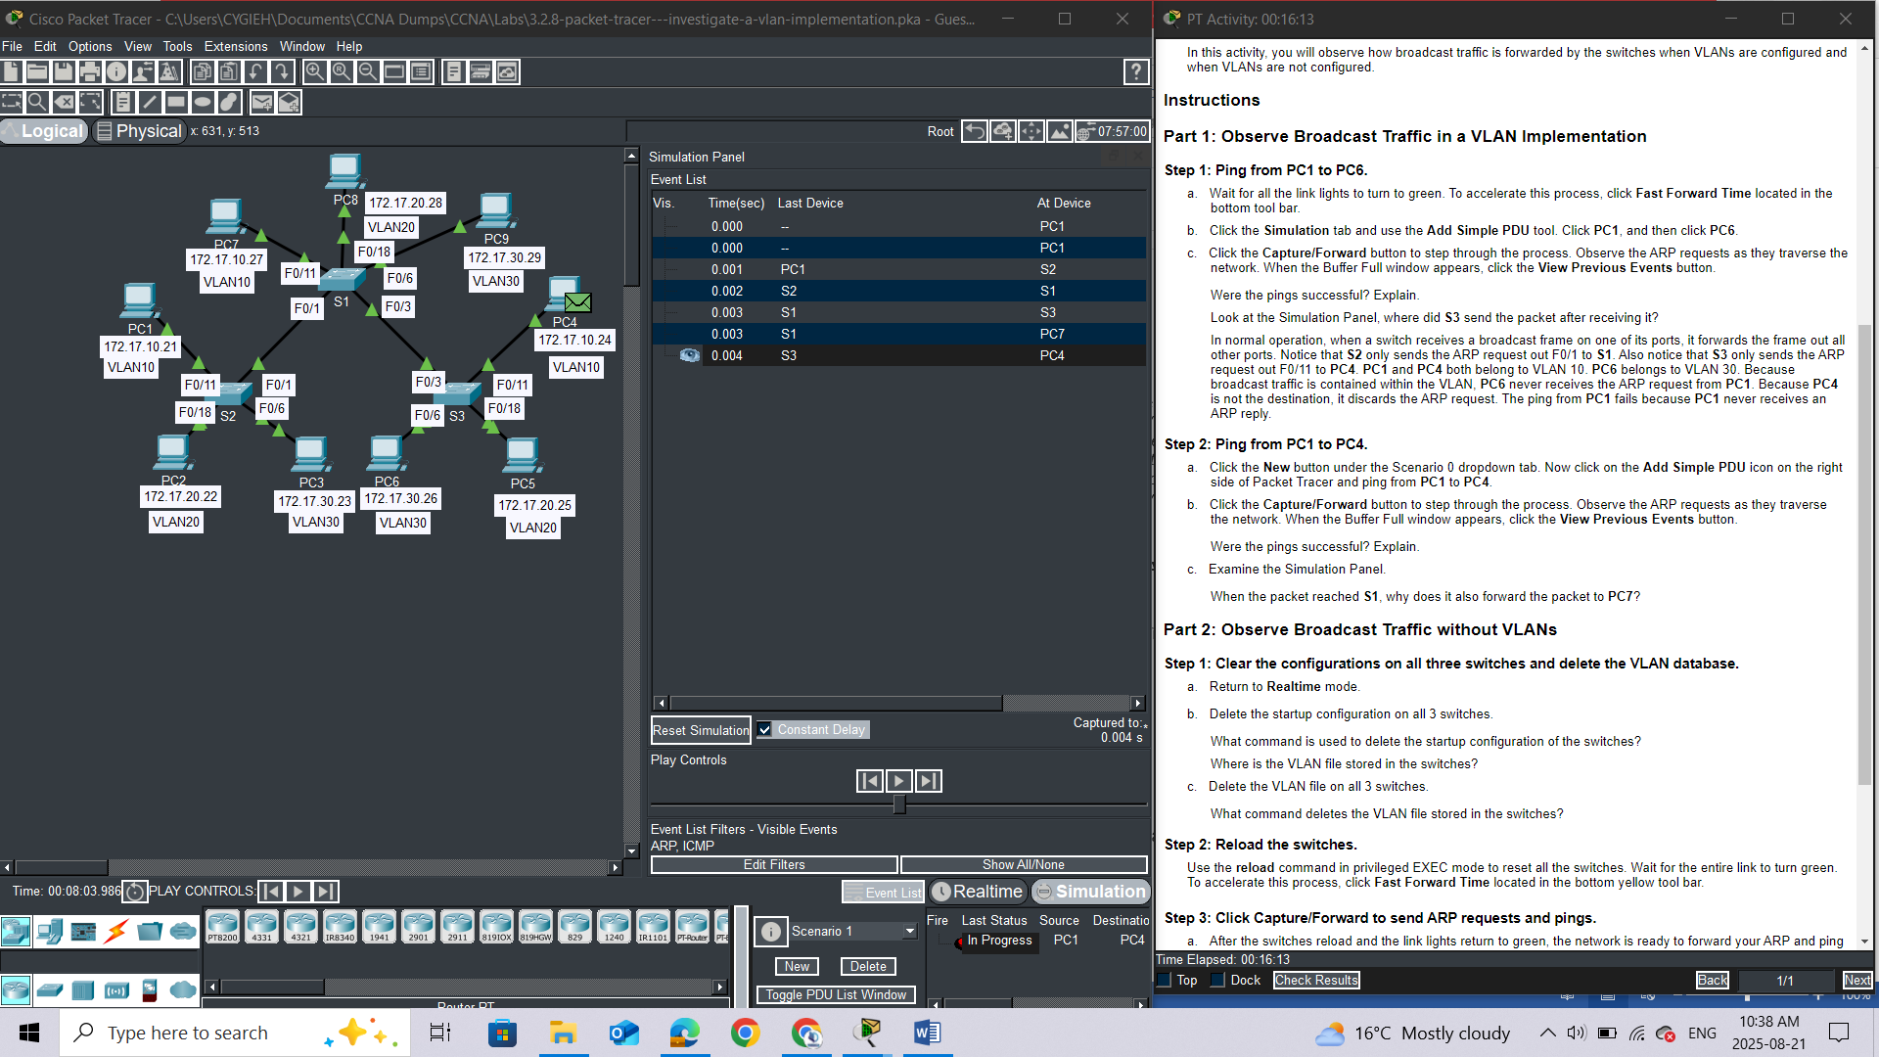

### Part 2: Observe Broadcast Traffic without VLANs

#### Step 1: Clear the configurations on all three switches and delete the VLAN database.

a.     Return to **Realtime** mode.

*Open configuration window*

1. Delete the startup configuration on all 3 switches.

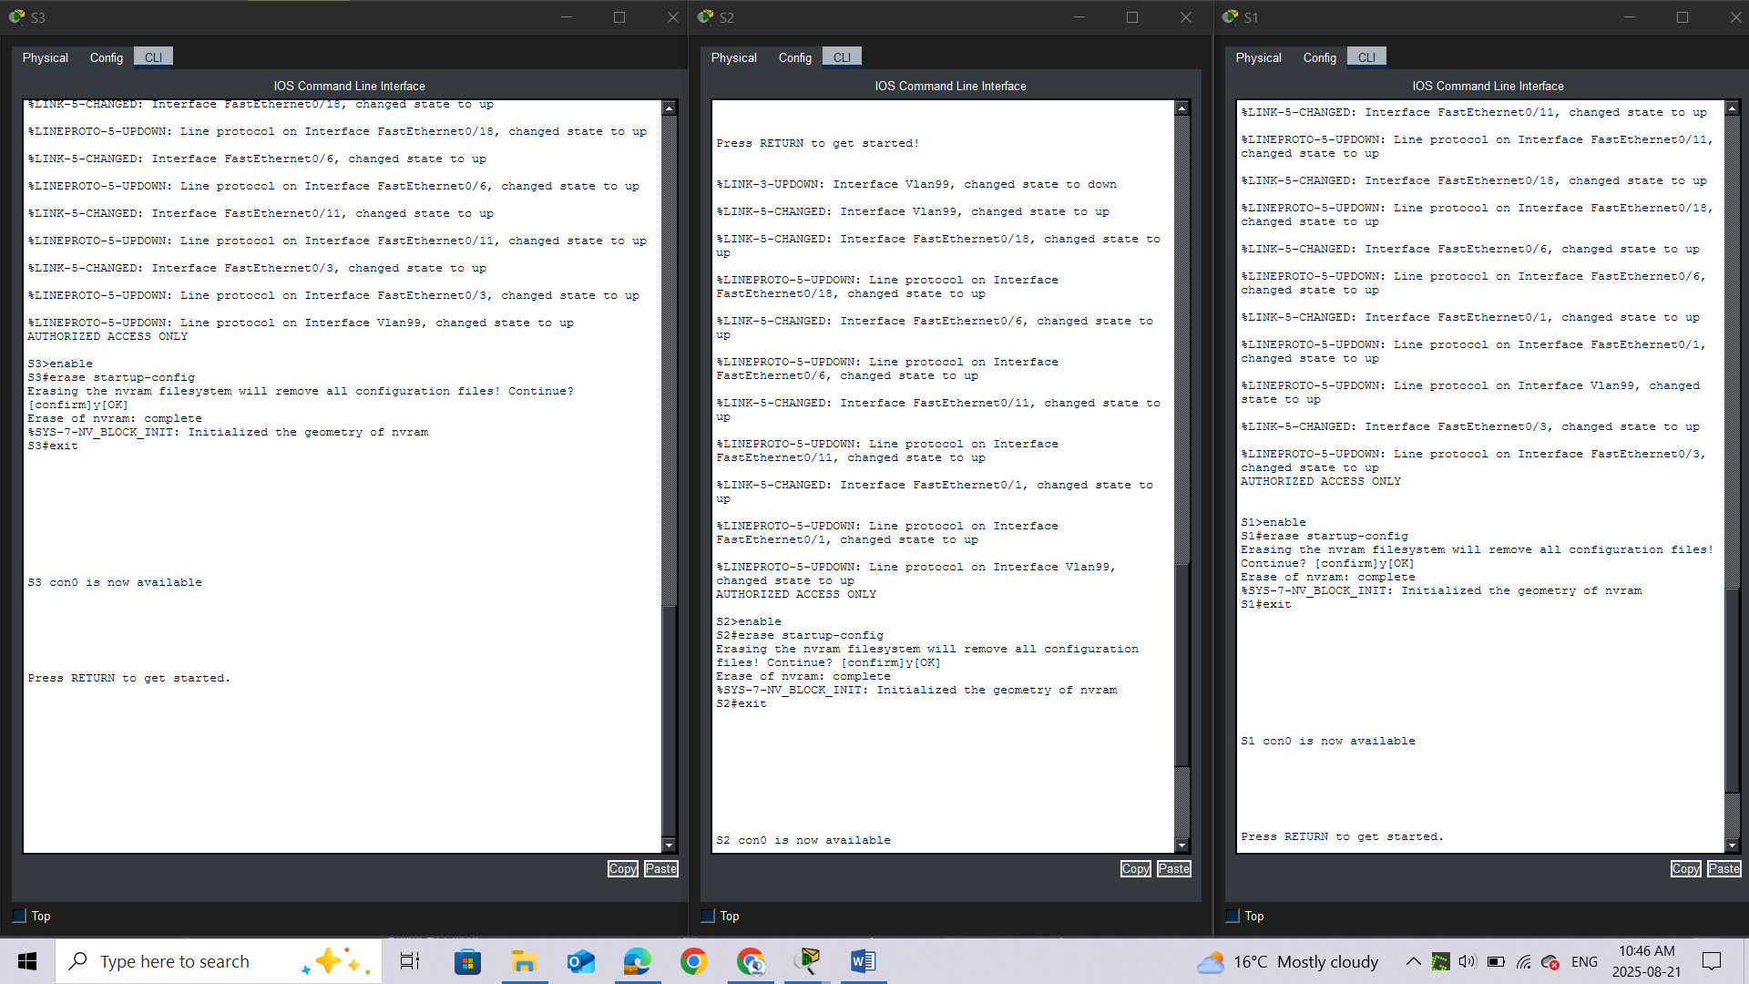

**Questions:**

What command is used to delete the startup configuration of the switches? ***erase startup-config***

Where is the VLAN file stored in the switches? in [***vlan.dat***](https://www.google.com/search?rlz=1C1GCCU_enKE1161KE1161&cs=0&sca_esv=53bbb5633a515c6e&sxsrf=AE3TifO-j36IiuBvvxYySCaPkFHj58T0Hg%3A1755762510195&q=vlan.dat&sa=X&ved=2ahUKEwi-0-mFtZuPAxWJUaQEHeuxPBEQxccNegQIAhAB&mstk=AUtExfAe7y97b5KaOVbpXiiFL67wpjZc_cQ5xF6gmRYfw2lTtSZBlZekWrzDWZ6B763gxWdR78JFJmYBwDPWxJR-sKcqz1LBofPEkkm9TP1OAYjpzX9nGlMgHth88RiW5Ken-wfbcobGXoOkF_tHE7cqhmz_Zi6VlDXn9aF8LBZd79zoBaNkdjVpxAiocPp-6BXXBVm4izsoFwqSua2S3QqMGx5LuXAKrvy8LIXwNnRDZ6fRgXr_aPhsmPstwAsW6t6Tv0vhO_dAhHo7gk485NMmj1KA&csui=3)***, which resides in the switch's***[***flash memory***](https://www.google.com/search?rlz=1C1GCCU_enKE1161KE1161&cs=0&sca_esv=53bbb5633a515c6e&sxsrf=AE3TifO-j36IiuBvvxYySCaPkFHj58T0Hg%3A1755762510195&q=flash+memory&sa=X&ved=2ahUKEwi-0-mFtZuPAxWJUaQEHeuxPBEQxccNegQIAhAC&mstk=AUtExfAe7y97b5KaOVbpXiiFL67wpjZc_cQ5xF6gmRYfw2lTtSZBlZekWrzDWZ6B763gxWdR78JFJmYBwDPWxJR-sKcqz1LBofPEkkm9TP1OAYjpzX9nGlMgHth88RiW5Ken-wfbcobGXoOkF_tHE7cqhmz_Zi6VlDXn9aF8LBZd79zoBaNkdjVpxAiocPp-6BXXBVm4izsoFwqSua2S3QqMGx5LuXAKrvy8LIXwNnRDZ6fRgXr_aPhsmPstwAsW6t6Tv0vhO_dAhHo7gk485NMmj1KA&csui=3)***.***

1. Delete the VLAN file on all 3 switches.

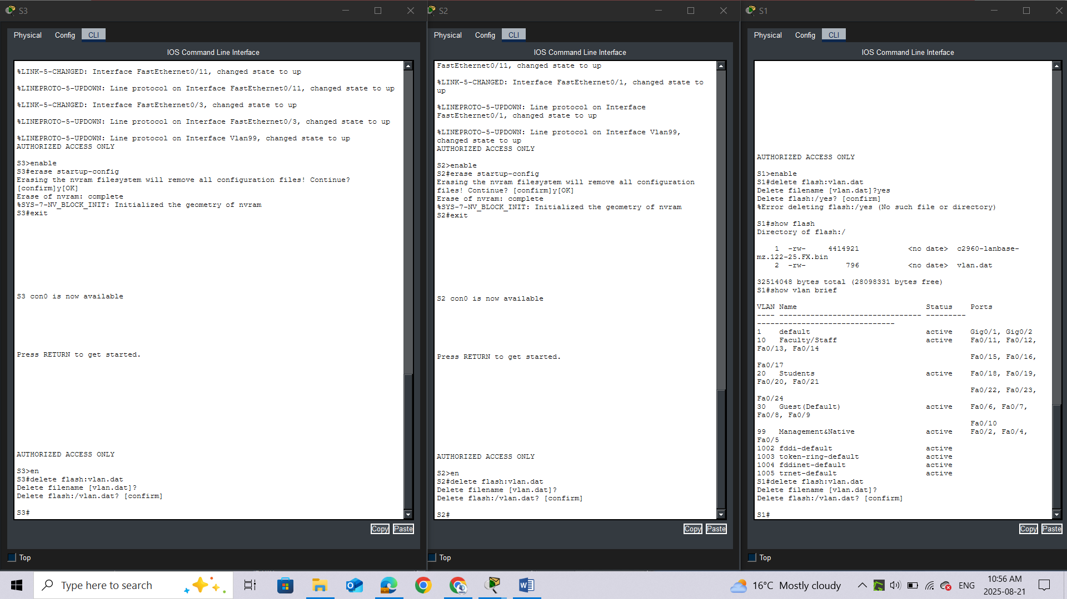

#### **Question:**

What command deletes the VLAN file stored in the switches? ***delete flash:vlan.dat***

### Step 2: Reload the switches.

Use the **reload** command in privileged EXEC mode to reset all the switches.

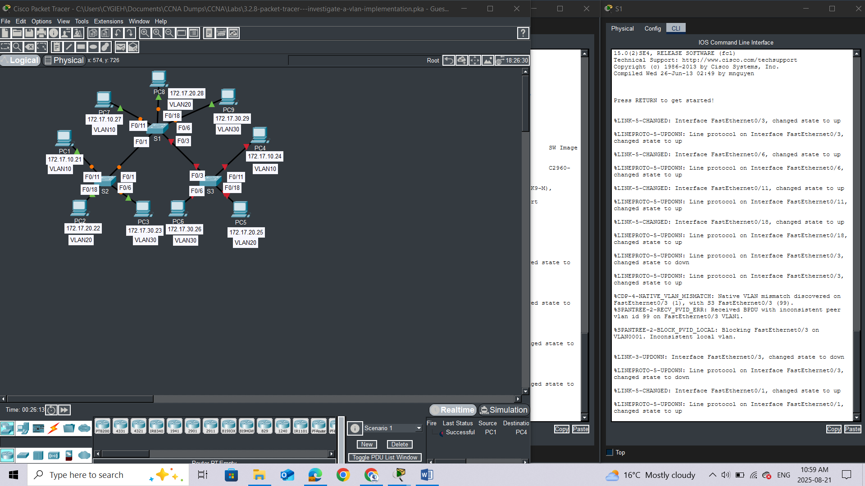

Wait for the entire link to turn green. To accelerate this process, click **Fast Forward Time** located in the bottom yellow tool bar.

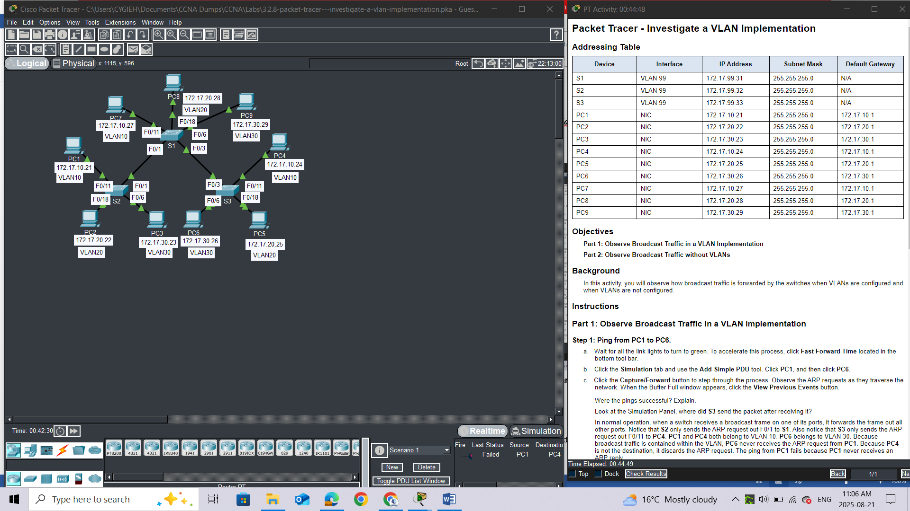

*Close configuration window*

### Step 3: Click Capture/Forward to send ARP requests and pings.

a.     After the switches reload and the link lights return to green, the network is ready to forward your ARP and ping traffic.

b.     Select **Scenario 0** from the drop-down tab to return to Scenario 0.

c.     From **Simulation**mode, click the **Capture/Forward** button to step through the process. Notice that the switches now forward the ARP requests out all ports, except the port on which the ARP request was received. This default action of switches is why VLANs can improve network performance. Broadcast traffic is contained within each VLAN. When the **Buffer Full** window appears, click the **View Previous Events** button.

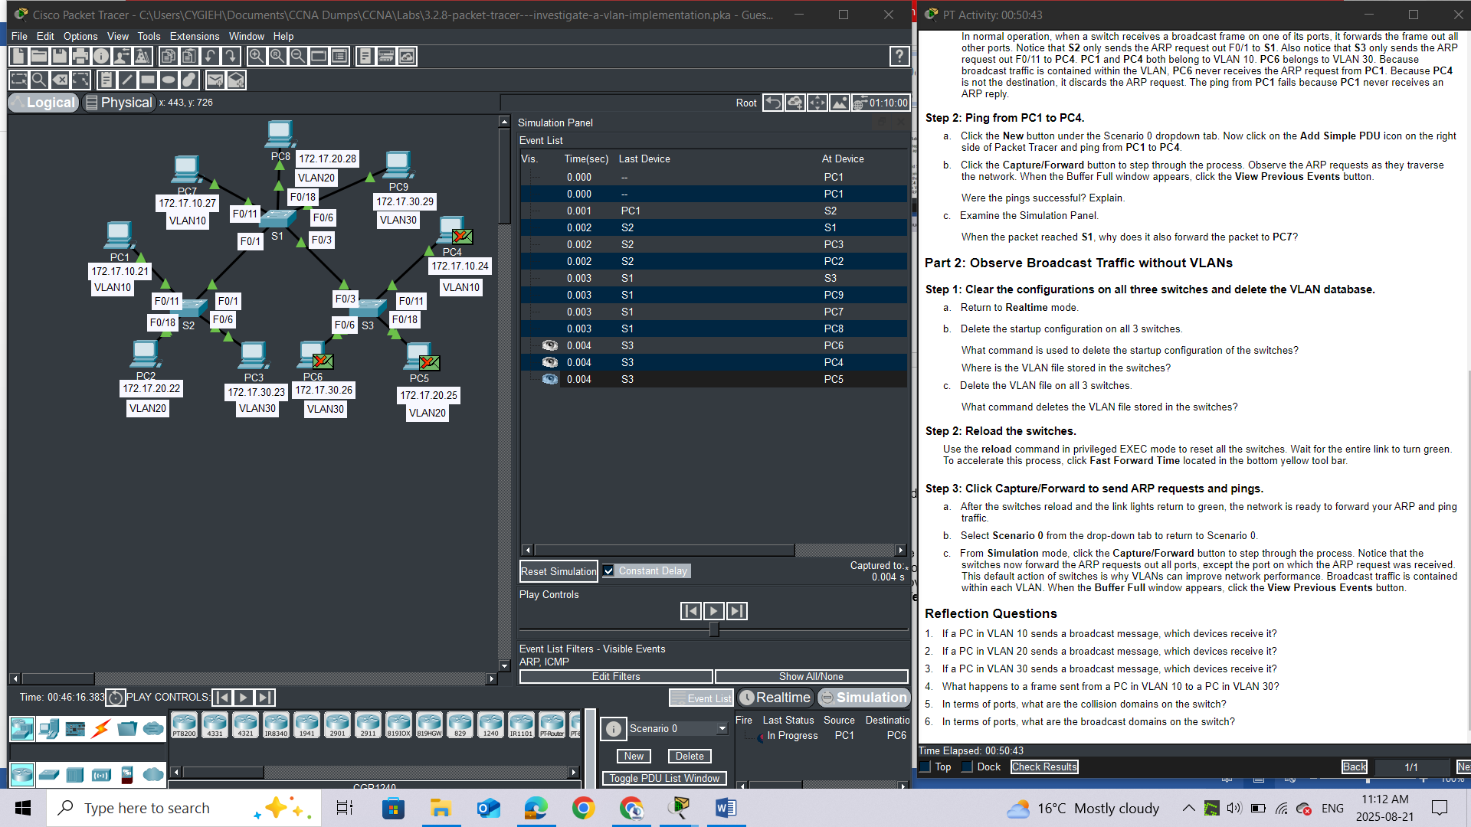

### Reflection Questions

1.     If a PC in VLAN 10 sends a broadcast message, which devices receive it? All devices

2.     If a PC in VLAN 20 sends a broadcast message, which devices receive it? All devices

3.     If a PC in VLAN 30 sends a broadcast message, which devices receive it? All devices

4.     What happens to a frame sent from a PC in VLAN 10 to a PC in VLAN 30?

5.     In terms of ports, what are the collision domains on the switch?

6.     In terms of ports, what are the broadcast domains on the switch?